**IMPLEMENTING ENCRYPTION IN ANDROID VOTING SYSTEM CASE OF STIMA SACCO, NAIROBI COUNTY.**

**KANG’ETHE SAMWEL NDERITU**

**SCT221-5289/2015**

**A PROPOSAL SUBMITTED TO SCHOOL OF COMPUTING AND INFORMATION TECHNOLOGY IN PARTIAL FULFILMENT OF THE REQUIREMENT FOR THE BARCHELORS DEGREE IN NFORMATION TECHNOLOGY. DEPARTMENT OF INFORMATION TECHNOLOGY.**

**2019**

Declaration

I declare that this is my original project and the idea has not yet been presented in any of the degree or diploma for examination purposes.

NAME: SAMWEL NDERITU KANGETHE

REG NO: SCT221-5289/2015

Signature: _____________________

Approval

SUPERVISOR: PAMELA NEONDO

Signature: _____________________

Date: _________________________

1. **Table of Contents**

1.1 Research Area 1

1.2 Problem Statement 2

1.3 Proposed Solution 3

1.4 Objectives 3

1.5 Research Questions 3

1.6 Project Justification 4

1.7 Project Scope 4

1.8 Methodology 4

1.8.1 Object Oriented Analysis and Design (OOAD) 4

1.8.2 Phases of Design Cycles 5

1.8.3 Inception 5

1.8.4 Elaboration 5

1.8.5 Construction 5

1.8.6 Transition 5

1.9 Data Collection Techniques 5

1.9.1 Interviews 5

1.9.2 Observation 6

1.9.3 Questionnaire 6

1.10 Resource Requirement 6

1.10.1 Hardware requirements 6

1.10.2 Software Requirements 6

1.10.3 Other requirements 6

1.11 Budget 7

2 Literature Review 10

2.1 Theoretic Framework 10

2.2 Election 10

2.3 Types of Voting 10

2.4 Critique of Existing Methods 11

2.5 Identified Research Gaps 11

3 System Analysis and Design 12

3.1 Data collection techniques 12

3.1.1 Direct Observation 12

3.1.2 Questionnaires 12

3.2 Data analysis 12

3.2.1 Analysis of the findings 12

3.2.2 Report of Questionnaires 13

3.3 Feasibility Study 14

3.3.1 Technical Feasibility 14

3.3.2 Economic feasibility 14

3.3.3 Operational Feasibility 15

3.3.4 Schedule feasibility 15

3.3.5 Social feasibility. 15

3.4 FUNCTIONAL REQUIREMENTS 15

3.5 NON-FUNCTIONAL REQUIREMENTS: 16

3.6 Physical design 16

3.7 Logical design 18

3.8 Database design 20

3.9 References: 22

3.10 Sample Questionnaire 23

Table 1: Budget 7

Table 2: Project Time Plan 8

Table 3 Gantt Chart 9

Table 4: people involved 12

Table 5: registration Details 21

Table 6 : Vote Table 21

Table 7: Admin Table 22

Figure 1: Acceptability by Age 13

Figure 2: Pie chart on online literacy 13

Figure 3: physical Design log in Figure 4 Physical design Home Screen 17

Figure 5: Log out screen 18

Figure 6 Class Diagram 19

Figure 7 Sequence Diagram 19

Figure 8 Use Case Diagram 20

1. Introduction

Stima Sacco is a licensed Sacco that started in the year 1974 with an aim of lifting member’s social lifestyle and wellbeing. Stima Sacco was to enhance members’ individual socio-economic status by way of mobilization f savings and afford them credit at fair and reasonable rates.

In the year 2003, it introduced Front Office Service Activities (FOSA). From then up to now it has eight branches countrywide in Nairobi(Parklands), Mombasa, Kisumu, Nakuru, Olkaria, Eldoret, Nairobi Ngara, Embu and Kawi Centre (South C) . Its head office are located in Ngara 3 kilometers from Nairobi CBD.

The organization is headed by a CEO Chris Useki. The chief manager is second in the ranking, followed by chief manager finance and finally the head of credit operations manager. Each station has over 50 employees where each station has a head who reports to the senior most position who is the CEO.

It has a wide range of savings products. These products are tailored to meet various needs of a diversified membership with each member’s unique need being catered for in this array of products and services .They include savings products and credit services.

## Research Area

**Encryption**

Encryption is the technique by which plaintext or some other sort of information is changed over from a clear structure to an encoded rendition that must be decoded by another substance in the event that they approach an unscrambling key (Himanshu Agarwal,2016). Encryption is a standout amongst the most significant techniques for giving information security, particularly for start to finish insurance of information transmitted crosswise over systems (Prof. S.M. Jambhulkar, 2013).

The voting system will offers users various options for secure authentication. All procedures ensure eligible voters can participate in the election only once. To maintain ballot secrecy, a token (anonymous and untraceable back to individual voter identity) is generated for each voter when logging into the system.

When someone logs into the voting system, the admin roll registers the query and checks the user’s eligibility to vote. If the user is eligible to vote, the admin roll requests a token from the validator. This token is generated by the system and isn't seen by voters. The token confirms the voter’s identity in order to maintain ballot secrecy. Once successfully authenticated, the voter is forwarded to the online ballot when completed ballots are submitted to the digital ballot box, the token is not saved. Once the final vote has been cast.

Here are ways which encryption will be maintained

Authentication process

When an eligible voter logs into voting system with a voter-ID and password, a private key and a hashed password are generated in their client from the password. The private key serves as a signature on the voters’ submitted ballot.

Highest level of security for your election

Secrecy of the ballot and data protection are maintained at all times. Moreover, the system will only allow voters to cast their vote once.

Secure Authentication

The voting system will be both secure and maintain ballot secrecy. By using various authentication procedures, voters can login and vote whilst maintaining ballot secrecy.

## Problem Statement

Voting is a method for a group, such as a meeting or an electorate, in order to make a collective decision or express an opinion, usually following discussions, debates or election campaigns (Himanshu Agarwal,2016). Democracies elect holders of high office by voting. There are different systems for collecting votes. In the case of stima Sacco members are supposed to vote during AGMS so as to elect the members they wish to represent them in their affairs. They are supposed to elect the board of directors, managing director, national treasurer and a delegate. **This process** happens annually. At Stima Sacco there is manual voting where members are supposed to produce their membership card to be allowed to vote for the above positions. With this it’s faced with different challenges such as the process is tedious, time consuming, a lot of resources are used to hold one election.

With the process of voting being centralized, authenticating the real owner of the card is a problem. In case of external calamities such as fire the whole voting process has to be repeated due to centralization.

## Proposed Solution

As a result of the problem stated, proposed solution is to develop an app that will automate voting process. The proposed system will allow voters to log in and interact with the system. The system will be distributed allowing shareholders regardless of where they are and they can vote their preferred leadership regardless of the time and place they are. Unlike the current system where membership card was used for verification, authentication will be used for verification which will It will help in analyzing data and presenting actionable information that helps shareholders to execute, help them make informed business decisions. The system will be able to perform some sort of tallying after voting. The system shall also allow voting where the shareholders are able to vote and results are displayed openly to everyone. The following are the goals of the proposed system;

Every voter shall cast only one vote

It must be impossible to change anybody’s vote

The complete voting procedure must be so transparent

User friendly

Transparency; users can check the system integrity without any trouble.

## Objectives

To design, develop and implement an efficient, user friendly, interactive voting system.

To develop a system that will facilitate voting.

To develop a system that will facilitate voters and candidates interactions.

To develop a system that will generate reports for the election process

## Research Questions

The proposed system is based on the following research questions.

How will the proposed system capture voters’ details?

How will the proposed system facilitate voting?

How will the proposed system generate reports for the election process?

## Project Justification

The research will benefit both my client (Stima Sacco) and its shareholders. The shareholders will take less time to vote, they will also use less resources and the process will be free and fair hence benefiting both the shareholders and the Sacco. With the proposed solution, it intends to maximize the number of shareholders and minimizing the cost. This will be achieved through the app where anyone can vote at any given time. It saving on time, resources and also making sure it has maintained high integrity. With recent change of time information technology has become core of any successful business. The proposed system will also ensure transparency and high integrity in the election process. The system will be user friendly and provide great efficiency in the election process. Its success can also be replicated in other.

## Project Scope

For the purpose of coming up with a voting system the scope will only cover the Nairobi region part of Kenya. This will be a pilot study that will later be implemented on other branches of the Sacco in the country.

## Methodology

### Object Oriented Analysis and Design (OOAD)

Object oriented analysis and design (OOAD) concepts can be applied in the phases of software development life cycle (analysis, design, and implementation). It is very important to understand the OO analysis and design concepts

#### The unified Process

The unified process is a traditional cathedral style of incremental design driven by constructing views of system architecture.

It has the following key features:

It is component based, commonly being used to coordinate object oriented programming projects.

It uses UML a diagrammatic notation for object oriented design.

The design process is anchored, and driven by use cases which help keep sight of the anticipated behaviors of the system.

It is architecture centric and its design is iterative and incremental via a prescribed sequence of design phases within a cyclic process.

### Phases of Design Cycles

Design in the unified Process proceeds through a series of cycles, each of which has the following phases:

### Inception

Produces a commitment to go ahead and by the end of this phase a business case should have been made, feasibility of the project assessed, and the scope of the design should be known.

### Elaboration

Leads to a working specification of the system and the end of this phase a basic architecture should have been produced a plan of construction agreed, all significant risks identified, and those risks considered to be major should have been addressed.

### Construction

Produces beta-release system and the end of this phase a working system should be available, sufficient for preliminary testing under realistic conditions.

### Transition

Introduces the system to its intended user

## Data Collection Techniques

This are the techniques that will used to fact find and expound on the research.

### Interviews

Interview can be conducted in person or over the telephone. It will involve direct players to the Sacco. Interviews will be formally done .the questions will be focused, clear and encourage open ended response .they are mainly qualitative in nature. The interview will be done to both the shareholders and the management of stima Sacco.

### Observation

Observation will help study the dynamics of a situation, frequency counts of target behaviors, or other need s as indicated by need of the evaluation (Himanshu Agarwal,2016). Good source for providing additional information in particular group, can use video as a form of storing data or even record. They can also be used for documentation. Attending AGMS to fact find on various issues pertaining the research. An advantage of observation is it can produce qualitative and quantitative.

### Questionnaire

This is the process of giving random people who are directly or indirectly involved in matters of the Sacco. This include the shareholders staff, and the board members .the results in questionnaire are generally easy because the questions are direct such that one does not answer the questions that he/she is not asked . The researcher defines the direction he wants response on. It’s easier in that it can be analyzed and compared to a different set of questionnaire.

## Resource Requirement

### Hardware requirements

Computer system with the following specifications:

Memory (RAM) - 4 GB RAM and above recommended.

Hard disk space – 250 GB or above of available hard disk space.

C.P.U –processor 2.4 GHz or higher

### Software Requirements

Windows 7 operating system and above

Database (MySQL)

Antivirus (Avast)

Android studio

### Other requirements

Wi-Fi (modem)

Printing

Stationery

## Budget

|  |  |  |  |
| --- | --- | --- | --- |
| **ITEM** | **PRICE PER UNIT** | **NO. OF UNITS** | **TOTAL** **(KSH)** |
| Computer unit | 25000 | 1 | 25,000.00 |
| Other software | 10000 |  | 10,000.00 |
| Antivirus | 1,000 | 1 | 1,000.00 |
| Modem | 3000 | 1 | 3,000.00 |
| Miscellaneous expenses | 3000 |  | 3,000.00 |
| Total |  |  | 32,000.00 |

Table 1: Budget

|  |  |  |  |  |  |  |  |
| --- | --- | --- | --- | --- | --- | --- | --- |
|  | **Description** | **Duration**  **(Weeks)** | **Proposed Start date** | **Proposed Finish date** | **Actual Start Date** | **Actual Finish Date** | **Deliverables** |
| 1 | Project Identification | 2 | 1/12/18 | 31/12/19 | 14/1/18 | 28/1/2018 | Problem statement definition |
| 2 | Draft Proposal  Writing | 2 | 2/1/2019 | 16/1/2019 | 28/1/2019 | 10/2/2019 | Draft Proposal |
| 3 | Final Proposal | 2 | 12/1/2019 | 28/1/2019 | 10/2/2019 | 12/2/2019 | Final Proposal |
| 4 | Literature Review | 3 | 20/1/2019 | 13/2/2019 | 4/3/2019 | 22/3/2019 | Literature review report |
| 5 | Data collection  And analysis | 4 | 20/1/2019 | 14/3/2019 | 25/4/2019 | 19/4/2019 | Requirements specification |
| 7 | System design | 4 | 1/3/2019 | 29/3/2019 | 23/4/2019 | 10/5/2019 | System design |
| 8 | System Development | 6 | 9/3/2018 | 27/4/2019 |  |  | Working System |
| 9 | Testing | 3 | 1/5/2019 | 21/5/2019 |  |  | Working System |
| 10 | Project Report | 28 | 12/12/18 | 15/6/2019 |  |  | Project Report |

Table 2: Project Time Plan

|  |  |  |  |  |  |  |  |  |  |  |  |  |  |  |  |  |  |  |  |  |  |  |  |  |  |  |  |  |  |  |  |  |  |  |
| --- | --- | --- | --- | --- | --- | --- | --- | --- | --- | --- | --- | --- | --- | --- | --- | --- | --- | --- | --- | --- | --- | --- | --- | --- | --- | --- | --- | --- | --- | --- | --- | --- | --- | --- |
| **Activities** |  | **Jan** | | | | **Feb** | | | | **March** | | | | **April** | | | | **May** | | | | **June** | | | | **July** | | | | | **August** | | | |
| **Week** | **Hrs.** | **1** | **2** | **3** | **4** | **1** | **2** | **3** | **4** | **1** | **2** | **3** | **4** | **1** | **2** | **3** | **4** | **1** | **2** | **3** | **4** | **1** | **2** | **3** | **4** | **1** | **2** | **3** | **4** | **1** | | **2** | **3** | **4** | |
| Project Identification | 3 |  |  |  |  |  |  |  |  |  |  |  |  |  |  |  |  |  |  |  |  |  |  |  |  |  |  |  |  |  | |  |  |  | |
|  |  |  |  |  |  |  |  |  |  |  |  |  |  |  |  |  |  |  |  |  |  |  |  |  |  |  |  |  | |  |  |  | |
| Draft Proposal  Writing | 8 |  |  |  |  |  |  |  |  |  |  |  |  |  |  |  |  |  |  |  |  |  |  |  |  |  |  |  |  |  | |  |  |  | |
|  |  |  |  |  |  |  |  |  |  |  |  |  |  |  |  |  |  |  |  |  |  |  |  |  |  |  |  |  | |  |  |  | |
| Final Proposal | 8 |  |  |  |  |  |  |  |  |  |  |  |  |  |  |  |  |  |  |  |  |  |  |  |  |  |  |  |  |  | |  |  |  | |
|  |  |  |  |  |  |  |  |  |  |  |  |  |  |  |  |  |  |  |  |  |  |  |  |  |  |  |  |  | |  |  |  | |
| Literature Review | 8 |  |  |  |  |  |  |  |  |  |  |  |  |  |  |  |  |  |  |  |  |  |  |  |  |  |  |  |  |  | |  |  |  | |
|  |  |  |  |  |  |  |  |  |  |  |  |  |  |  |  |  |  |  |  |  |  |  |  |  |  |  |  |  | |  |  |  | |
| Data collection and analysis | 12 |  |  |  |  |  |  |  |  |  |  |  |  |  |  |  |  |  |  |  |  |  |  |  |  |  |  |  |  |  | |  |  |  | |
|  |  |  |  |  |  |  |  |  |  |  |  |  |  |  |  |  |  |  |  |  |  |  |  |  |  |  |  |  | |  |  |  | |
| System design | 48 |  |  |  |  |  |  |  |  |  |  |  |  |  |  |  |  |  |  |  |  |  |  |  |  |  |  |  |  |  | |  |  |  | |
|  |  |  |  |  |  |  |  |  |  |  |  |  |  |  |  |  |  |  |  |  |  |  |  |  |  |  |  |  | |  |  |  | |
| System Development | 48 |  |  |  |  |  |  |  |  |  |  |  |  |  |  |  |  |  |  |  |  |  |  |  |  |  |  |  |  |  | |  |  |  | |
|  |  |  |  |  |  |  |  |  |  |  |  |  |  |  |  |  |  |  |  |  |  |  |  |  |  |  |  |  | |  |  |  | |
| Testing and Implementation | 12 |  |  |  |  |  |  |  |  |  |  |  |  |  |  |  |  |  |  |  |  |  |  |  |  |  |  |  |  |  | |  |  |  | |
|  |  |  |  |  |  |  |  |  |  |  |  |  |  |  |  |  |  |  |  |  |  |  |  |  |  |  |  |  | |  |  |  | |
| Project Report | 24 |  |  |  |  |  |  |  |  |  |  |  |  |  |  |  |  |  |  |  |  |  |  |  |  |  |  |  |  |  | |  |  |  | |
|  |  |  |  |  |  |  |  |  |  |  |  |  |  |  |  |  |  |  |  |  |  |  |  |  |  |  |  |  | |  |  |  | |

Table 3 Gantt Chart

KEY:

Proposed time  Actual time

# Literature Review

This chapter documents the available relevant literature of the problem domain. The implication was that the researcher devoted sufficient time to reviewing research already undertaken on related problems. This event was done to learn what data and other materials are already available from earlier research, and identify gaps that the present research may fill.

## Theoretic Framework

The Stima Sacco voting app will allow members to log in or create an account generated once one becomes a member of the Sacco. After logging in, they will then select their leader of choice in various positions and vote. After voting, they will log out and they will later be notified on elections' outcome via the same app after the votes have been counted.

The main purpose of this research is to increase election integrity. The app will be accessible by a member of the Sacco across the globe only when there’s an election happening or some by-laws that need to be passed.

## Election

An election gives people the right to select candidates to represent them in a democratic pattern (K. P. Kaliyamurthie,2013) . Election deals with the democracy and free will of citizens, then, the voting process is considered to be a very critical and sensitive process, therefore election implementation must serve many requirements in order to deliver a trustworthy election. These requirements can be defined as user convention's requirements and delivery of secure voting process requirements.

The world is going toward the use and implementation of technology in every aspect of our life including e-governments due to the fast development of network technologies. Online voting is one of technologies. Online voting refers to the use of hardware and software to establish an electronic system, useful in the voting process, by generating an electronic ballot replacing the paper ballot. This system of voting was introduced by governments especially in Europe so as to serve voting convention (Prof. S.M. Jambhulkar, 2013).

Providing a remote system so to allow the voters can cast their votes whenever and wherever he/she can. These systems will increase the voter's participation and will speed up the votes counting. Introducing remote voting technique over the internet will serve the voter's convention. The main idea of this technology is to speed up the ballot counting and increase voters' participation by providing remote voting processes and social interaction platform

## Types of Voting

Voting is a process at the heart of a democratic society. There is a wide variety of different voting systems that are based on traditional paper ballots, mechanical devices, or electronic ballots.

In recent years, voting equipment's which were widely adopted in many countries may be divided into five types

**Paper-based voting**: The voters get a blank ballot and use a pen or a marker to indicate who he wants to vote for which candidate. Hand-counted ballots is a time and labor consuming process, but it is easy to manufacture paper ballots and the ballots can be retained for verifying, this type is still the most common way to vote.

**Lever voting machine:** Lever machine is peculiar equipment, and each lever is assigned for a corresponding candidate(Himanshu Agarwal,2016).. The voter pulls the lever to poll for his favorite candidate. This kind of voting machine can count up the ballots automatically. Because its interface is not user-friendly enough, giving some training to voters is necessary.

**Direct recording electronic voting machine:** This type, which is abbreviated to DRE, integrates with a keyboard; touch screen or buttons for the voter press to poll. Some of them lay in voting records and counting the votes is very quickly. But the other DRE without keep voting records are doubted about its accuracy.

Punch card: The voter uses metallic hole-punch to punch a hole on the blank ballot. It can count votes automatically, but if the voter’s perforation is incomplete, the result is probably determined wrongfully.

**Optical voting machine:** After each voter fills a circle corresponds to their favorite candidate on the blank ballot, this machine selects the darkest mark on each ballot for the vote then computes the total result. This kind of machine counts up ballots rapidly. However, if the voter fills over the circle, it will lead to the error result of the optical-scan.

**Electronic voting:** is a voting system where the recording, casting, and counting of votes involves information and communication technology(Prof. S.M. Jambhulkar, 2013). The main principle of the e-voting system is the replica of the regular voting system as much as possible. It is compliant with the election legislation and principles and be at least secure as the regular voting. In a nutshell, e-voting strives to be uniform and secret, only eligible persons are to be allowed to e-vote and a voter should only cast one vote

**Online Voting:** this is just like electronic voting but only that it is a web-based system. In this paper, a new easy to use, secure and transparent online voting system is proposed (Pranay R. Pashine, Dhiraj P. Ninave,2015). The new scheme can be easily used by colleges and universities worldwide. The new scheme most notable allows voters to interact, participate in campaigns and political rallies virtually by use of a web-based system.

## Critique of Existing Methods

Low voters turn out this is resulted by fixed voting day and some members willing to the voter are maybe held by unavoidable circumstances or the cost of coming to voting stations.

Election rigging this is resulted by few individuals who would prefer a certain person in power for their own personal gain.

Cost the current system is expensive to hold. This is resulted by the large labor force needed to man the election and the cost printing ballot papers.

## Identified Research Gaps

Lack of transparency in the election systems

Lack of robust and error-free systems for the election process.

# System Analysis and Design

## Data collection techniques

### Direct Observation

Direct observation helped to get real time scenario of what was happening on the ground based on the experimental outcomes. This approach is in the primary data collection where observation in the case on the ground keenly from past elections.

### Questionnaires

Here, formulated questions which both were open ended and close ended and were issued to the stakeholders (organization managers and technical staff) who complied by giving their responses. This tool helped in the collection of data on the daily activities that were being carried out.

Advantages

Was easy to analyze data since the questions that was asked were straight forward.

Reduced Bias in that most of the questions were in closed format and had answers and therefore answers were straight forward.

It was relatively quick to collect information since most of the people that were required to answer the questions were available when needed.

## Data Analysis

### Analysis of the findings

Below are the individuals who were involved during the data collection phase.

|  |  |
| --- | --- |
| People Involved in Data Collection Process | Number of People Involved |
| Senior Managers | 5 |
| Stima staff | 10 |
| Shareholders | 20 |
| Technical staff | 5 |
| Total | 30 |

Table 4: people involved

### Report of Questionnaires

After collecting the data using this tool, the following graphs shows the analysis of some of the major questions contained in the questionnaires for the stakeholders

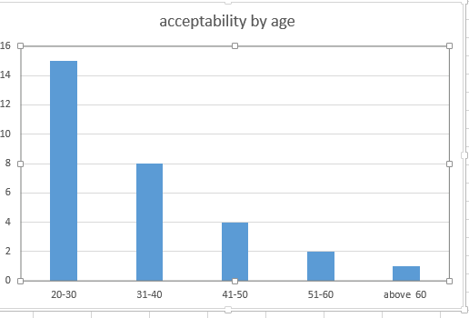

Figure 1: Acceptability by Age

The figure below shows the sampled data from the stakeholders on how familiar they are with online voting.

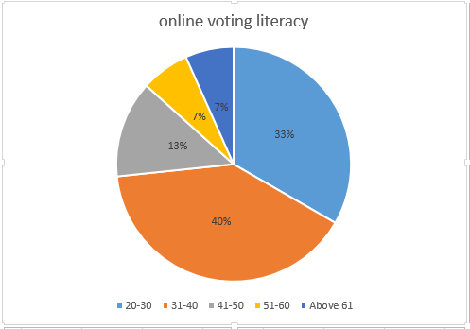

Figure 2: Pie chart on online literacy

## Feasibility Study

Depending on the results of the initial investigation the survey is now expanded to a more detailed feasibility study. Feasibility study is a test of system proposal according to its workability, impact of the organization, ability to meet needs and effective use of the resources. Some of the feasibility study carried during the research include:

### Technical Feasibility

A study of resource availability that may affect the ability to achieve an acceptable system (DavSrivatsan Sridharan,2016). This evaluation determines whether the technology and the technical support needed for the proposed system is available or not.

Can the work for the project be done with current equipment existing software technology & available personal?

Can the system be upgraded if developed?

If new technology is needed then what can be developed?

This is concerned with specifying equipment and software that will successfully satisfy the user requirement. The research carried showed that the project is technically feasible

### Economic Feasibility

This study looked at the financial assessment of the project in terms of cost-benefit analysis. It basically ensures that the system will be affordable by the Sacco and its shareholders when implemented. Economic justification is generally the “Bottom Line” consideration for most systems. Economic justification includes a broad range of concerns that includes cost benefit analysis. In this we weight the cost and the benefits associated with the candidate system and if it suits the basic purpose of the organization i.e. profit making, the project is making to the analysis and design phase.

According to the analysis done, the organization will incur some cost in hiring the technical staff and also the shareholders will also need to purchase an android phone (platform the system will run) so as to vote. However, despite these costs the organization and the shareholders are able and willing to invest in this project since the major problems they face will be minimized thus this project will be economically feasible.

### Operational Feasibility

Operational feasibility refers to the proportion of taking care of issues with the assistance of another proposed framework. It helps in exploiting the chances and satisfies the prerequisites as recognized during the improvement of the task. It takes care that the administration and the clients bolster the venture. It is mainly related to human organizations and political aspects. Some of the things to consider are:

What changes will be brought with the system?

What organization structures are disturbed?

What new skills will be required? Do the existing staff members have these Skills? If not, can they be trained in due course of time?

The system is operationally feasible as it very easy for the End users to operate because they only needs basic information about using an android smartphone and they will be good to go.

### Schedule Feasibility

Time evaluation is the most important consideration in the development of project. The time schedule required for the developed of this project is very important since more development time effect machine time, cost and cause delay in the development of other systems.

A reliable voting app can be developed in the considerable amount of time. It can take up to a maximum of 2 months moths to develop. This will include voters’ registration and education.

### Social Feasibility.

Social feasibility is one of the feasibility study where the acceptance of the people is considered regarding the product to be launched.

It describes the effect on users from the introduction of the new system considering whether there will be a need for retraining the workforce.

It describes how you propose to ensure user co-operation before changes are introduced.

## Functional Requirements

Functional requirements try to explain the basic functions of the system intended. The system will do the following:

Recognize and Authenticate users’ credentials.

Registration of the voter is done by the Sacco once one is declared a shareholder.

Voter is given a unique ID and PASSWORD.

Voter can give vote after login and entering the ID and PASSWORD.

In the DATABASE information of every voter is stored.

Display voting results

## Non-Functional Requirements

The non -functional requirements are as follows:

**Maintainability** The experts should have the ease of maintaining the system by, correcting errors, preventing breakdown, perfecting the system and ensuring that it adapts to the changing technology and needs of the user.

**Usability** The system will be friendly to all users with or without much knowledge due to simple user interfaces and proper documentation of the system.

**Economical** The system will be affordable and within the budget specified.

## Physical Design

The physical design is concerned with how the physical architecture of the entire system interacts to achieve its objectives ( Dr. Mahmood Khalel Ibrahem, 2012) . Modelled the user interfaces, the server architecture and the database models. This is where a new user/voter starts; the individual is required to provide a username and password. When this is provided, the system validates the user if the entered information tallies with what is in the database. He/she is then logged in and vote otherwise the voter/user isn’t logged in. it also offers a chance for the voter to see the results once they are tabulated. After voting the voter can then log out of the system.

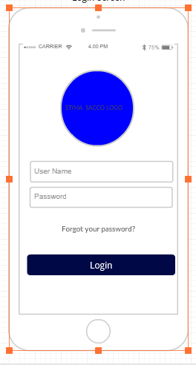 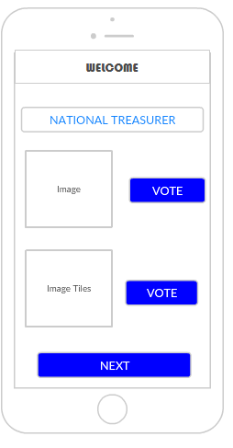

Figure 3: physical Design log in Figure 4 Physical design Home Screen

**Login**

It is the login session for the voter to proceed with the voting

**Username**

Each voter has unique username that will be generated by the admin

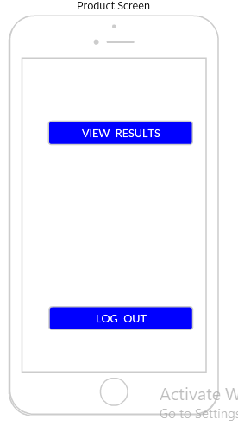

Figure 5: Log out screen

## Logical Design

Logical design characteristically looked at the intended system from a logical perspective without considering physical requirement. The project needed a logical design that modelled the flow of data and information through the system from input to output. Logical design also modelled the security checks that the system will be using as well as the formats for all data items in the system. The figure below shows a class diagram of the entire system.

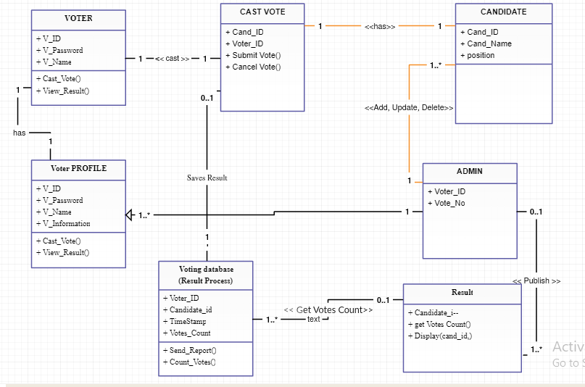

Figure 6 Class Diagram

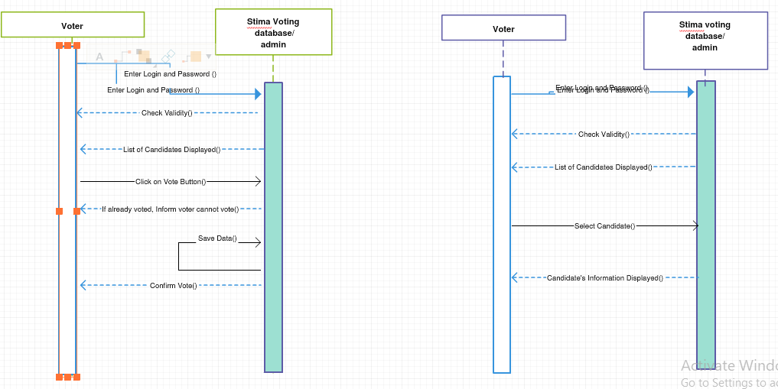

Figure 7 Sequence Diagram

The figure below also shows a use case diagram

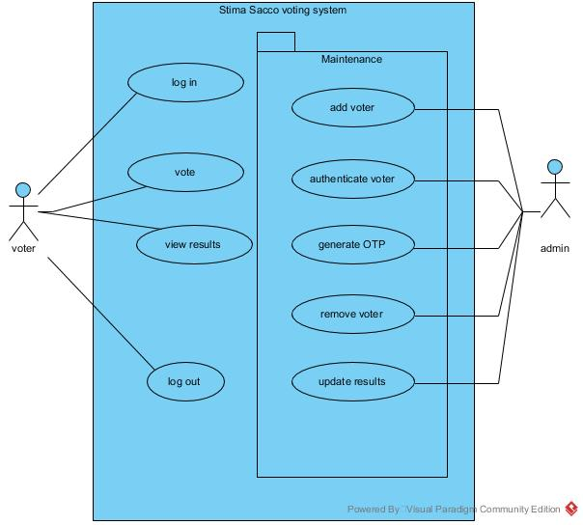

Figure 8 Use Case Diagram

## Database Design

This is the process of producing a detailed data model of the database. This data model contains all the needed logical and physical design choices and physical storage parameters needed to generate a design in a data definition language which can then be used to create database. This is also carried out in order to reduce redundancy of information. The Stima Sacco voting app will use a database as illustrated below;

**Registration details table-**the table holds records of registered users/voters with their respective preferred usernames and passwords. It also has the contacts {phone numbers, and email address} of voters/users

|  |  |  |  |
| --- | --- | --- | --- |
| **Field** | **Type** | **Null** | **Default** |
| ***ID No*** | int(10) | No |  |
|  | varchar(15) | No |  |
| Othername | varchar(15) | No |  |
| PhoneNo | varchar(15) | No |  |
| Email | varchar(50) | No |  |
| Username | varchar(15) | No |  |
| Password | varchar(20) | No |  |
| User | varchar(40) | No | Voter |

Table 5: registration Details

This same table is used by the user to get the username and password for logging in

**Vote table-**That holds records of the candidate, and the voter who casts a vote in favor of the candidate. Its primary key is the *id* field which is also necessary during vote counting. The database is queried to find out how many voters’ casts their votes for a given contestant.

|  |  |  |  |
| --- | --- | --- | --- |
| **Field** | **Type** | **Null** | **Default** |
| candidate | varchar(25) | No |  |
| Voter | varchar(15) | No |  |
| ***Id*** | int(8) | No |  |

Table 6 : Vote Table

|  |  |  |
| --- | --- | --- |
| **Field Name** | **Data type** | **Null** |
| Admin_Id | Int (10) | No |
| Username | Varchar(20) | No |
| Password | Varchar (20) | No |
| Phone | Int(20) | No |

Table 7: Admin Table

## References:

Himanshu Agarwal, G.N.Pandey, “Online Voting System for India Based on AADHAAR ID”, Eleventh International Conference on ICT and Knowledge Engineering 2013.

Srivatsan Sridharan , “ Implementation of Authenticated and Secure Online Voting System”, 4th ICCCNT 2013, Tiruchengode, India No.6, July 2013. IEEE – 31661.

Divya G Nair, Binu. V.P, G. Santhosh Kumar,” An Improved E-voting scheme using Secret Sharing based Secure Multi-party Computation”, arXiv: 1502.07469v1 [cs.CR] 26 Feb 2015

Prof. S.M. Jambhulkar, Prof. Jagdish B. Chakole, Prof. Praful. R. Pardhi “A Secure Approach for Web Based Internet Voting System using Multiple Encryption”, 2014 International Conference on Electronic Systems, Signal Processing and Computing Technologies,2014.

Pranay R. Pashine, Dhiraj P. Ninave, Mahendra R. Kelapure, Sushil L. Raut, Rahul S. Rangari, Kamal O. Hajari,” A Remotely Secure E-Voting and Social Governance System Using Android Platform”, International Journal of Engineering Trends and Technology (IJETT) – Volume 9 Number 13 - Mar 2014

Ms. Ashwini Walake, Prof. Ms. Pallavi Chavan,” Efficient Voting system with (2,2) Secret Sharing Based Authentication”, (IJCSIT) International Journal of Computer Science and Information Technologies, Vol. 6 (1) , 2015, 410-412

Firas I. Hazzaa, Seifedine Kadry, Oussama Kassem Zein,“Web-Based Voting System Using Fingerprin Design and Implementation”,International Journal of Computer Applications In Engineering Sciences ISSN: 2231-4946.

http://ieeexplore.ieee.org/xpl/articleDetails.jsp?tp=&arnumber=5578355&queryText%3DAndroid+based+shoping

http://ieeexplore.ieee.org/xpl/articleDetails.jsp?tp=&arnumber=6040585&queryText%3DAndroid+based+shoping

http://ieeexplore.ieee.org/xpl/articleDetails.jsp?tp=&arnumber=6234344&queryText%3DAndroid+based+shoping

Dr. Mahmood Khalel Ibrahem, Nada Mahdi Kiatan, Homormophic Encryption Protocol for Secure Electronic Voting System, 2012.

DavSrivatsan Sridharan , “ Implementation of Authenticated and Secure Online Voting System”, 4th ICCCNT 2013, Tiruchengode, India No.6, July 2013. IEEE – 31661.

Divya G Nair, Binu. V.P, G. Santhosh Kumar,” An Improved E-voting scheme using Secret Sharing based Secure Multi-party Computation”, arXiv: 1502.07469v1 [cs.CR] 26 Feb 2015

Prof. S.M. Jambhulkar, Prof. Jagdish B. Chakole, Prof. Praful. R. Pardhi “A Secure Approach for Web Based Internet Voting System using Multiple Encryption”, 2014 International Conference on Electronic Systems, Signal Processing and Computing Technologies,2014.

Pranay R. Pashine, Dhiraj P. Ninave, Mahendra R. Kelapure, Sushil L. Raut, Rahul S. Rangari, Kamal O. Hajari,” A Remotely Secure E-Voting and Social Governance System Using Android Platform”, International Journal of Engineering Trends and Technology (IJETT) – Volume 9 Number 13 - Mar 2014 Ms. Ashwini Walake, Prof. Ms. Pallavi Chavan,” Efficient Voting system with (2,2) Secret Sharing Based Authentication”, (IJCSIT) International Journal of Computer Science and Information Technologies, Vol. 6 (1) , 2015, 410-412

Himanshu Agarwal, G.N.Pandey, “Online Voting System for India Based on AADHAAR ID”, Eleventh International Conference on ICT and Knowledge Engineering 2013.

K. P. Kaliyamurthie, R. Udayakumar, D. Parameswari and S. N. Mugunthan , “highly secured online voting system over network”, 4833 Indian Journal Science and Technology Print ISSN: 0974-6846 Online ISSN: 0974- 5645 Vol 6 (6S) May 2013.

http://stima-sacco.com/index.php/about-stima-sacco/bod

## Sample Questionnaire

**I'm Nderitu Samwel from Jomo Kenyatta University of Agriculture and Technology. If it's not too much trouble take a couple of minutes to express your conclusions on the underneath inquiries. Your answers are essential to the accomplishment of this examination. Please answer with 'YES or NO' where required. This is the poll is aimed at improving and getting better services provided during AGM voting meeting.**

1. What’s your gender? Male [ ] Female [ ]
2. Are you going to vote in the coming elections? YES [ ] NO [ ] NOT SURE [ ]

|  |
| --- |
| If not, why aren’t you going to participate |
|  |
|  |

1. Are you conversant with online voting? YES [ ] NO [ ], if online voting was an option would you choose to use it? YES [ ] NO [ ]. If yes, why would you use online voting?

|  |
| --- |
|  |
|  |

If not, why not?

|  |
| --- |
|  |
|  |

1. Do you think online voting would significantly increase voter’s turnout?

YES [ ] NO [ ] NOT SURE [ ]

1. How long does it take to vote manually?

|  |
| --- |
|  |
|  |

1. Challenges faced when carrying out voting?

|  |
| --- |
|  |
|  |

1. Do you find the current system effective? YES [ ] NO [ ] NOT SURE [ ]

If NO, what recommendations would you give?

|  |
| --- |
|  |
|  |

Thank you for agreeing to take part in this survey. All of the answers you provide in this survey will be kept confidential. No identifying information will be provided to the public. The survey data will be reported in a summary fashion only and will not identify any individual person.